**SSN College of Engineering**

**Department of Computer Science and Engineering**

**UCS1512 – Microprocessors Lab**

**EX:11 – Dispay System Date and Time**

Exp No: 11 Name : Kshitij Sharma

Date: 15/10/2020 Reg No: 185001080

# Aim

To write programs to display the system date and system time in an 8086 microprocessor using MASM and DOSBox.

# Program to display the system date Algorithm

1. Define the values in the data segment and assign the initial values if required
2. Initialize the data segment register with a data segment address
3. Call the DOS Interrupt Function 21H with AH=2AH to obtain the system date: a. CX = year (1980-2099)
   1. DH = month
   2. DL = day
   3. AL = day of week (00h=Sunday)
4. Display the date in the desired format by loading into the appropriate variables
5. Terminate the program

|  |  |
| --- | --- |
| **Program** | **Comments** |
| start:  mov ax,data mov ds,ax | Initializing the data segment register with the data segment address |
| mov ah,2ah int 21h | Call the DOS Interrupt Function 21H with AH=2AH to get the system date |
| mov si,offset day mov [si],dl  mov si,offset month mov [si],dh  mov si,offset year mov [si],cx | Load the result of the DOS function into the appropriate memory locations for display |
| mov ah,4ch int 21h code ends  end start | Calling the DOS Function to enter the display screen using interrupt 21H and to terminate the program |

# Snapshots:

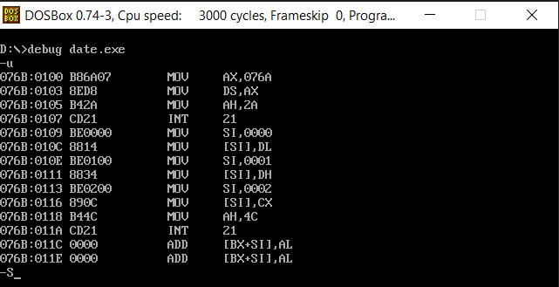

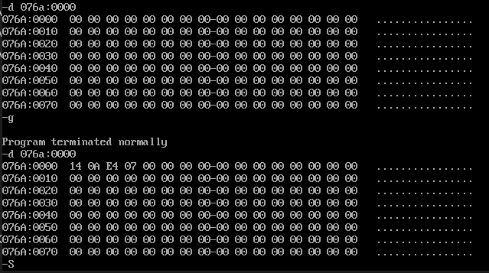

**Program to display the system time Algorithm**

1. Define the values in the data segment and assign the initial values if required
2. Initialize the data segment register with a data segment address
3. Call the DOS Interrupt Function 21H with AH=2CH to obtain the system time:
   * CH = hour
   * CL = minute
   * DH = second
4. Display the time in the desired format by loading into the appropriate variables
5. Terminate the program

|  |  |
| --- | --- |
| **Program** | **Comments** |
| start:  mov ax,data mov ds,ax | Initializing the data segment register with the data segment address |
| mov ah,2ch int 21h | Call the DOS Interrupt Function 21H with AH=2AH to get the system time |
| mov hour,ch mov minute,cl mov second,dh | Load the result of the DOS function into the appropriate memory locations for display |
| mov ah,4ch int 21h code ends  end start | Calling the DOS Function to enter the display screen using interrupt 21H and to terminate the program |

# Snapshots:

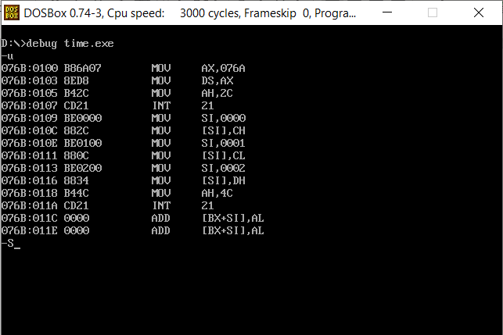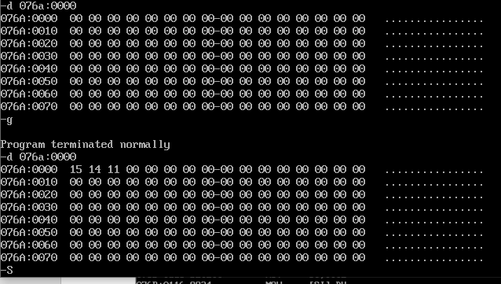

**Result**

Programs to display the system time and date in an 8086 microprocessor using MASM and DOSBox were implemented and the outputs were verified.